
An-Najah National University
Factuality of Engineering
Computer Engineering department
Software Engineering (10636312)

Happy Grade

JDI Group
Instructor’s Name : Shatha Ajaj

Lecture meeting :( 12 :30-2 :00)

Table of Contents

Table of Contents 2
Group member & activity 3
Calender 4
Add assessment page: 13
Interview with Customer 15
User Stories 16
UML for Project 17
PRODUCT BACKLOG 18
Get Hub link 21
Trello Link 22

Group member & activity

Name | ID | % worke
Mohee Qwareeq | 11821353 | 100/6
Hadi Nassar | 11820612 | 100/6
Ameer Yaish | 11819809 | 100/6
Mohammad Zaied | 11924576 | 100/6
Nasser Khaled | 11819303 | 100/6
Abd Al-kareem Salah | 11819572 | 100/6

Calender

Metting Date | Documentation
6/Oct/2021 | - In a lecture on Tuesday, we chose group from 6 members and created a messenger group to organize appointments and to facilitate communication.  - We wrote 17 User Stories for the system.
10/Oct/2021 | - In a lecture on Sunday, the team decided Scrum Master the student Amir Yaish .  - And we decided to call the team GDI, which is an abbreviation for ( just do it).  - We met with customer.
15/Oct/2021 | - We made a Zoom metting and we distribut the work into team member as this table :  Name ID Position  Ameer Yaish 11819809 Scrum Master  Mohee Qwareeq 11821353 Documentation  Mohammad Zaied 11924576 Documentation  Nasser Khaled 11819303 Programing  Abd Al-kareem Salah 11819572 Programing  Hadi Nassar 11820612 Programing
17/Oct/2021 | - Here the soties we start with :  - As a student I want to login.  - As a prof I want to login.  - As a TAs I want to login.  - As a student I want to edit my account information.  5- As a prof I want to edit my information.  6- As a TAs I want to edit my information.  - We identified an open source product name: Bees Gate

24/Oct/2021 | Sprint 1  We Start front-end for our system as picture below :  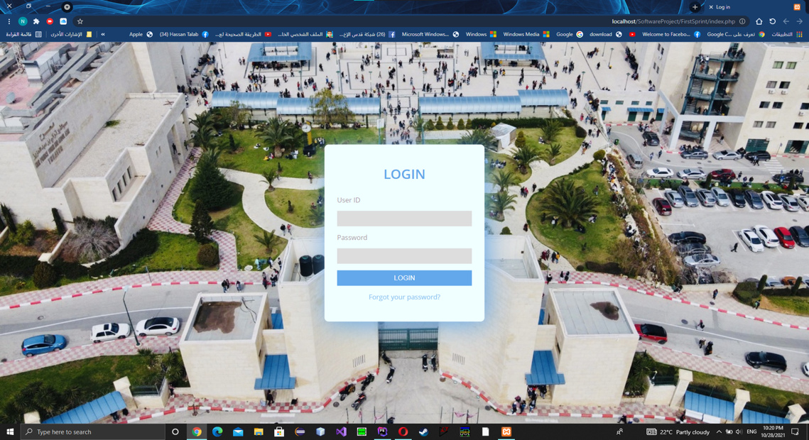  Sign in page  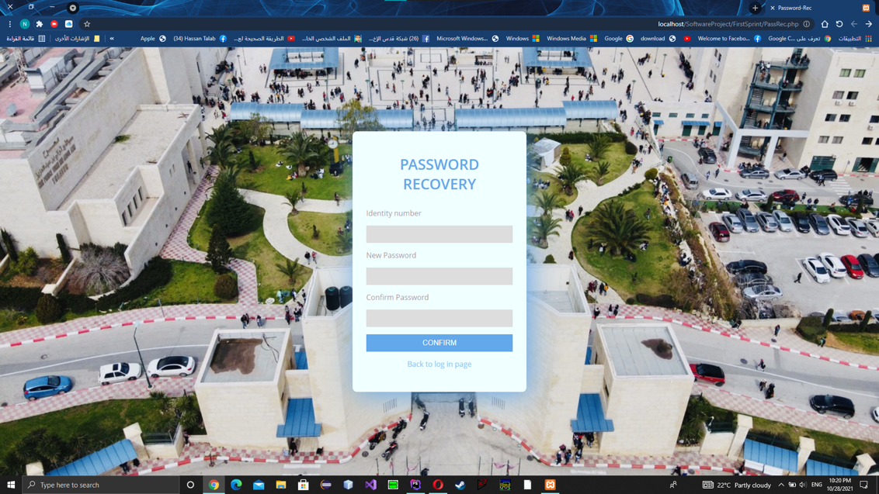  Page for edit information for all user
28/Oct/2021 | - We finished coding for the first sprint now we have a database and any user for the system can sign in his profile and edit his information like photos below :  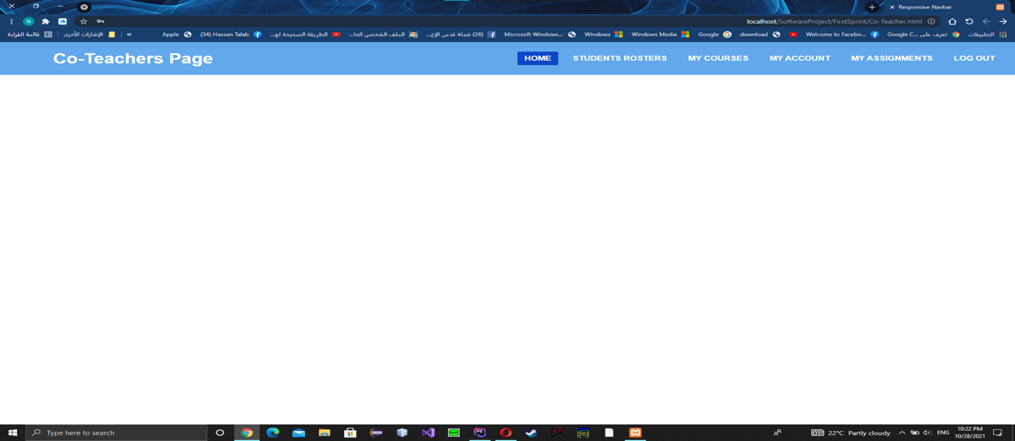  Page for TA’s  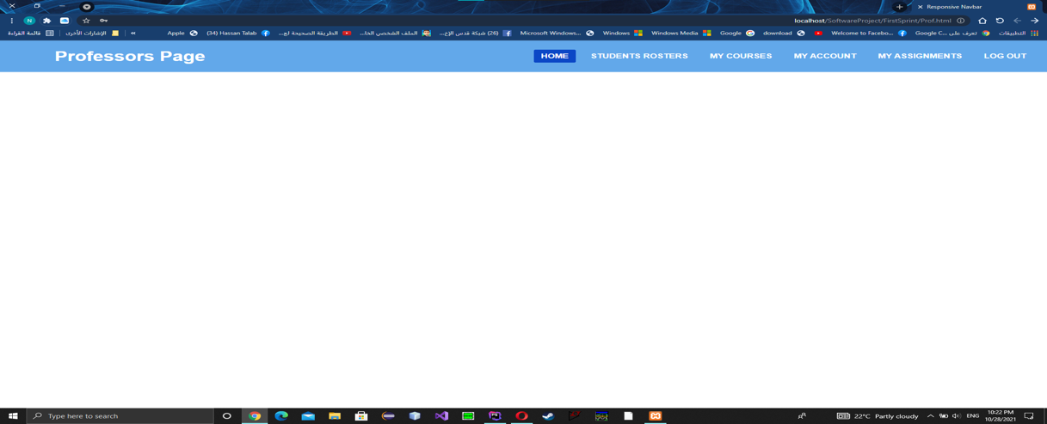  Page for professors  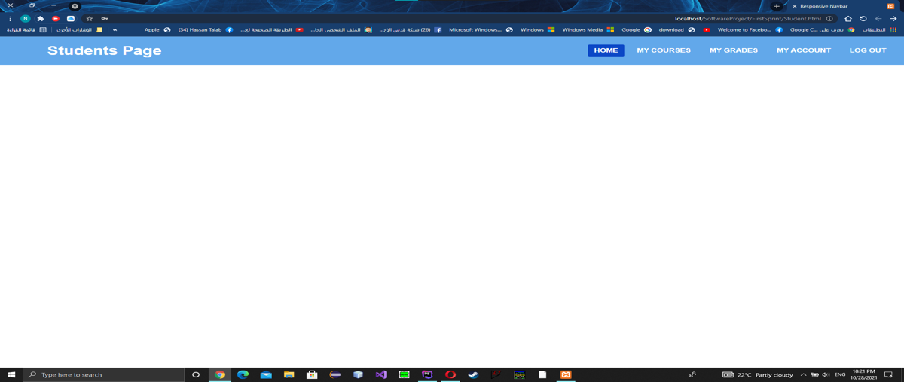  Page for student

Metting Date | Documentation
5/Nov/2021 | Sprint 2  - We start on sprint 2 which contain this user stories:  1-As a student, I need to be able to see registered courses,  2-As a student, I need to be able to see the instructor's name of my courses  3-As a student, I need to be able to see a description for my registered courses  4-As a professor or a Teacher Assistant I need to be able to see my courses  5-As a Teacher Assistant or a professor, I need to see the students which enrolled in the course  - Online zoom meeting we divided the tasks of programing.
10/Nov/2021 | - We Start on Teacher page which contain 4 main component  1-View Modules .  2-View Assessment .  3- View Marking schema .  4- View students.  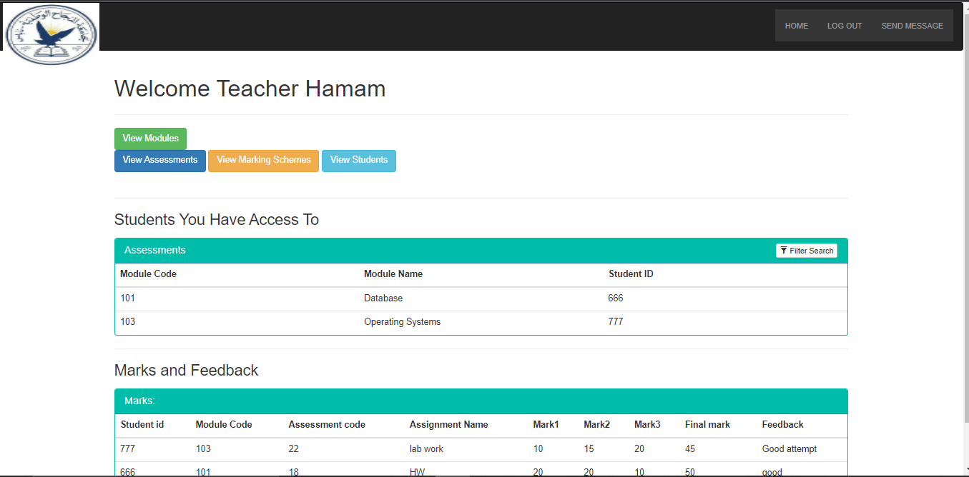

15/Nov/2021 | - We finished Teacher’s Page and below picture for each Subpages  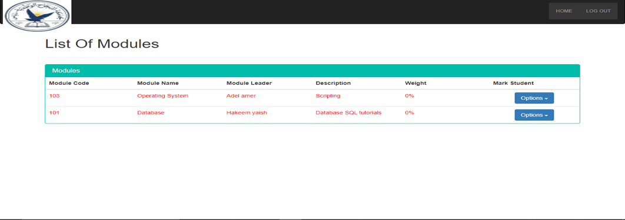  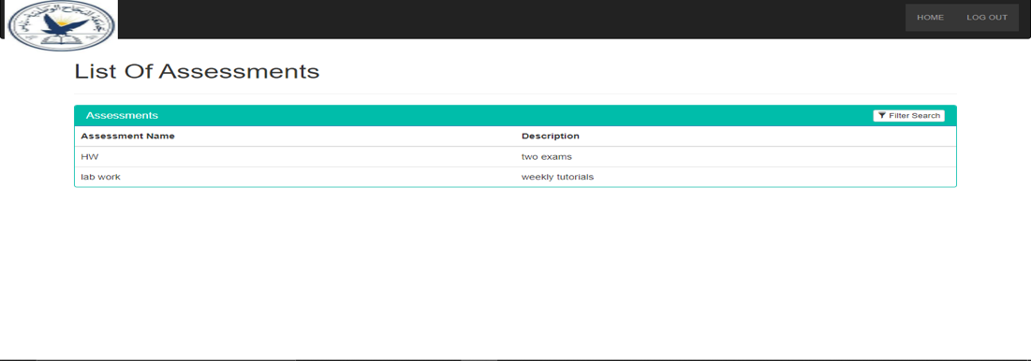  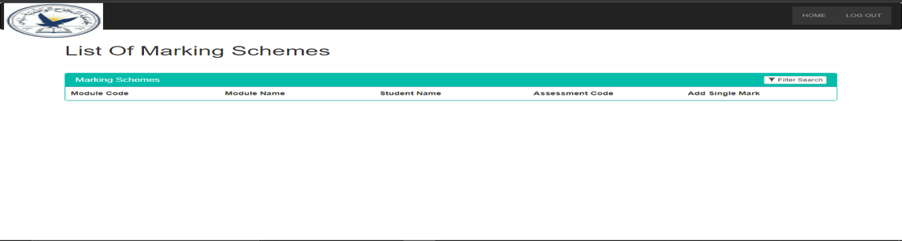  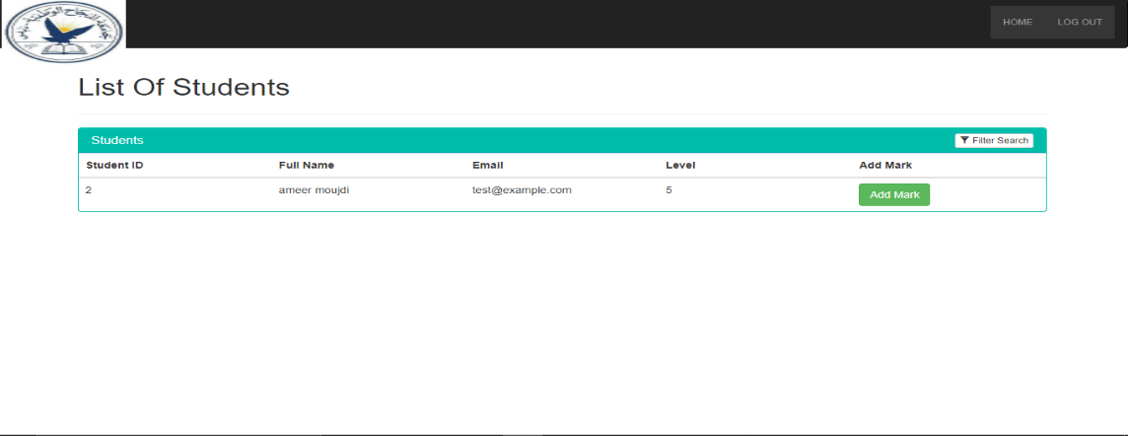

18/Nov/2021 | - We Start Professor’s Page and below main page picture.  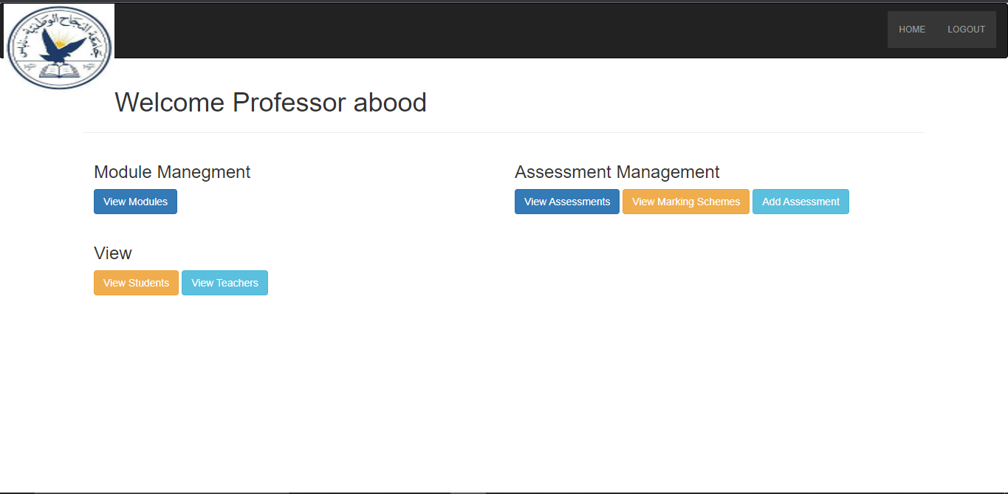
23/Nov/2021 | 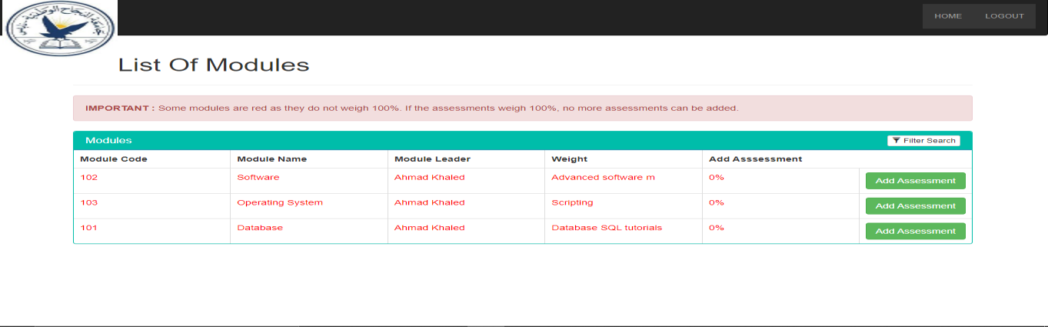  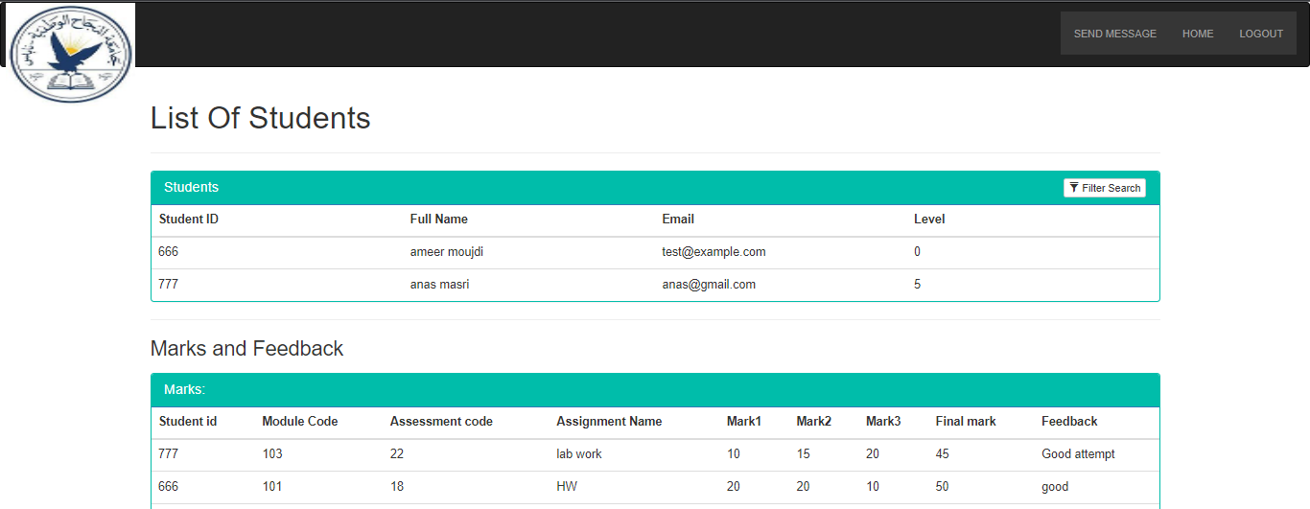

Metting Date | Documentation
28/Nov/2021 | - We finish the second sprint and finish all subpage for professors  And below there a photo:  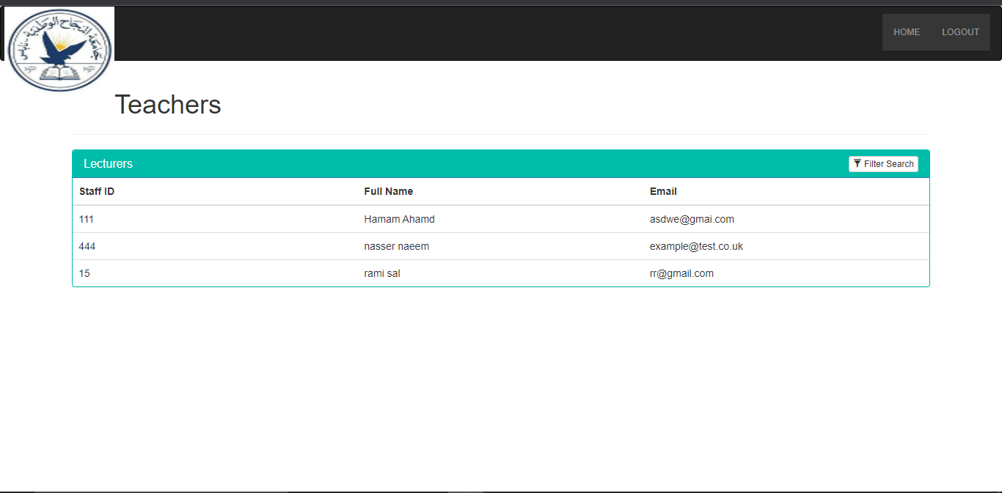  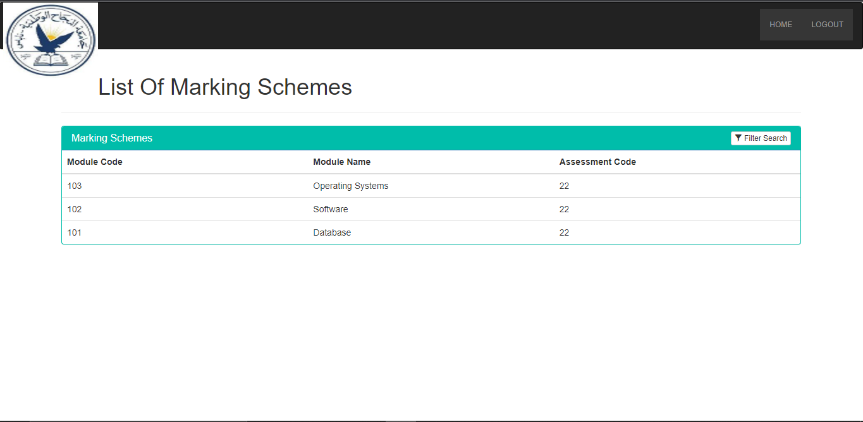

Metting Date | Documentation
29/Nov/2021 | Sprint 3  - We start on sprint 3 which contain this user stories:  1-As a Professor, I need to be able to add assignments for students  2-As a professor, I need to be able to Add grades for assignments.  3-As a student, I need to be able to see my grades only in assignments.  4-As a professor, I need to be able to edit the grade of assignments.  5-As a Teacher Assistant, I need to be able to write feedback about assignment for each student.
1/Dec/2021 | - We Start on student page and below main page picture.  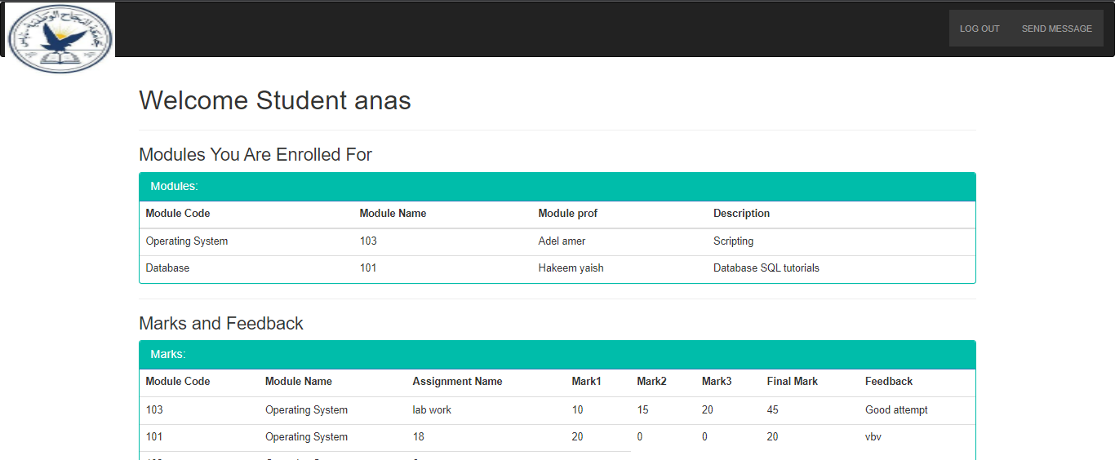

3/Dec/2021 | - We finish add mark page And below there a picture:  Add mark page:
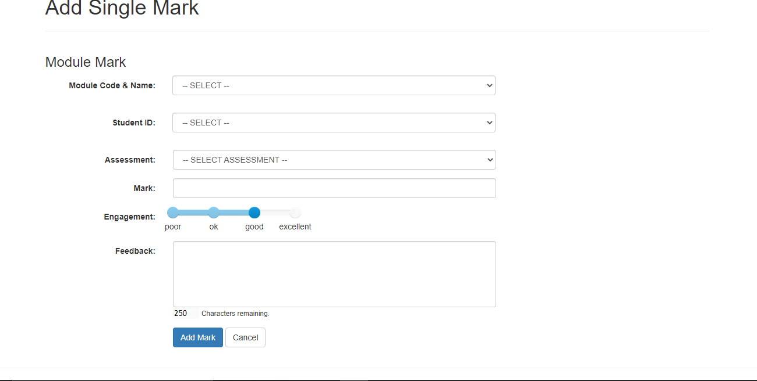

This page can access from prof and TAs , page contains fields that must be fill in to add the mark to the student :
- Module code & name : select code & name of module.
- Student id : select id of student.
- Assessment : select name of Assessment .
- Mark : add student’s mark.
- Engagement : select student’s rating.
- Feedback : prof write notes to students’.
- After fill all field click (add mark) to add student’s mark.

4/Dec/2021 | - We finish Add assessment page and finish the third sprint And below there a picture:  Add assessment page:
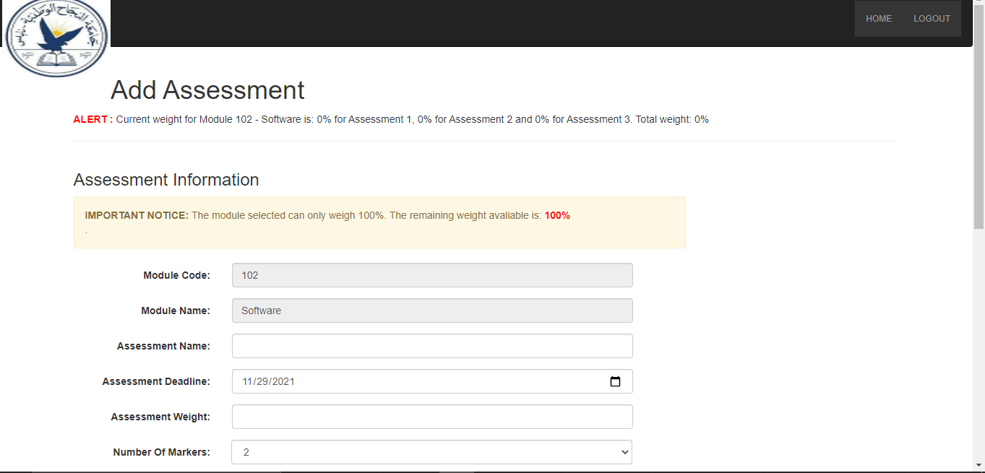

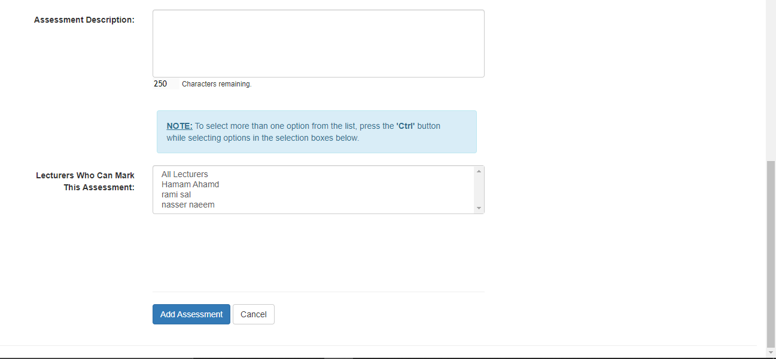
This page can access from prof only, page contains fields that must be filled in to add assessment to the student :
- Module code: fill code of module.
- Module name: fill name of module.
- Assessment name: put name of assessment.
- Assessment deadline: choice end date of assessment.
- Assessment weight: put weight of assessment.
- Number of mark : Put the rating mark from the total module.
- Assessment description : write description of the assessment.
- Lecture who can mark this assessment : write name of TAs who can add mark to student’s.

Metting Date | Documentation
8/Dec/2021 | We add some modifications that customer requested for  massage and comments  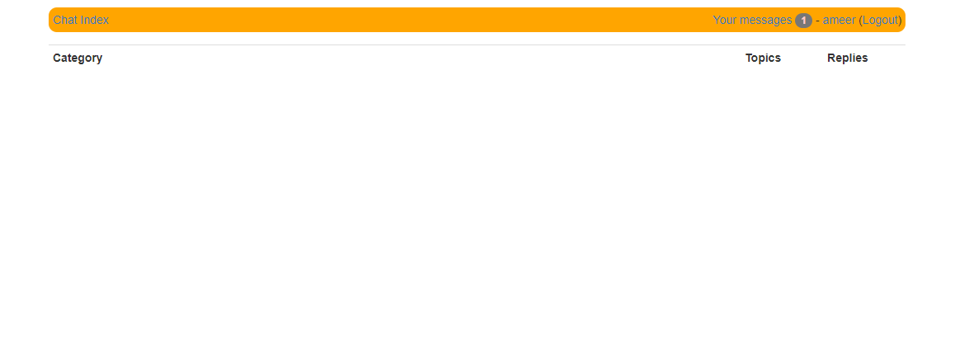  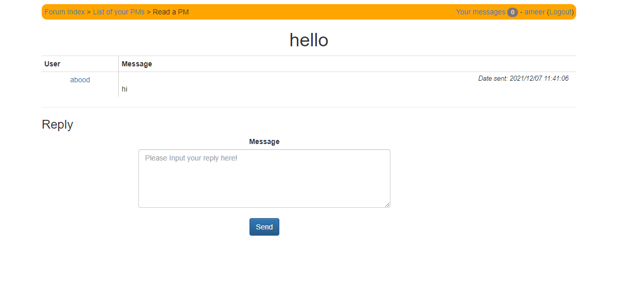  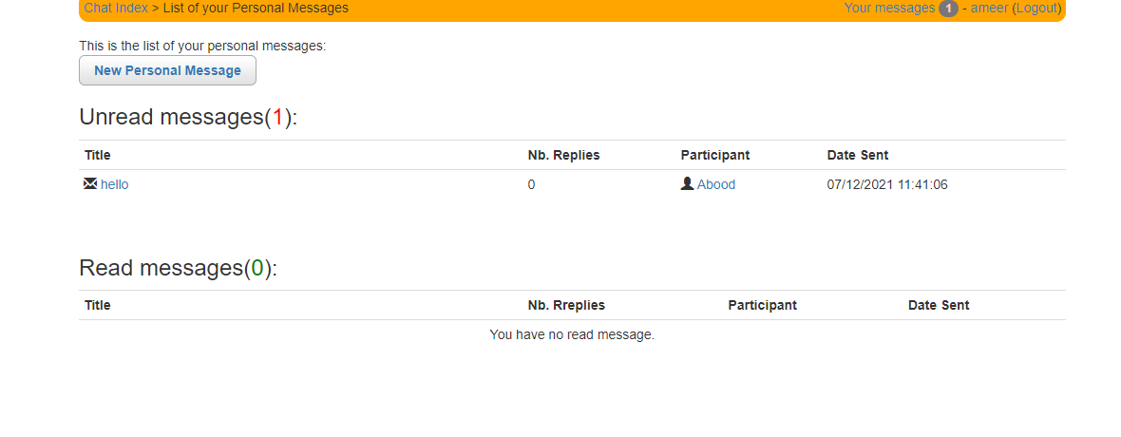  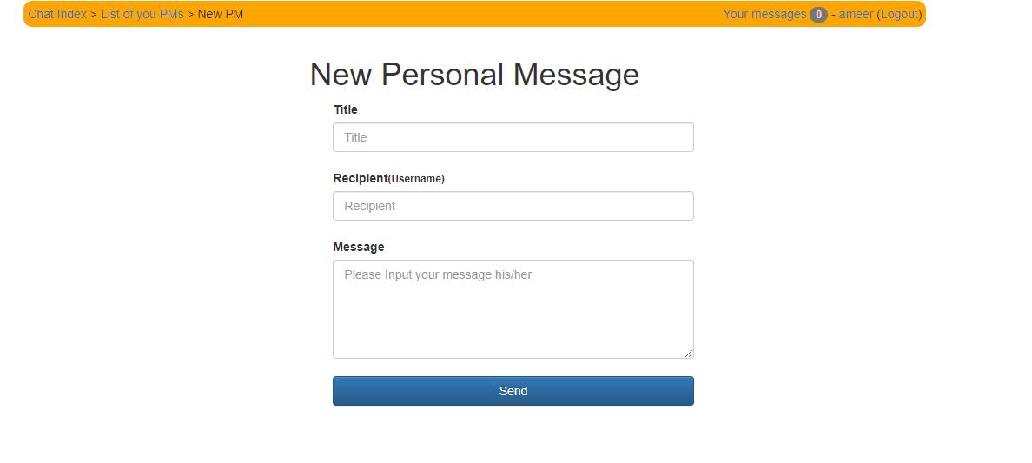

Interview with Customer

First interview (6/10/2021)
• The customer requested that there be a record show all modifications to the mark and be visible to the professor.

• The customer requested that there be messages between the students and the professor and be public.

• The customer requested that the color coordination be like the Model site of An-Najah University.

Questions:
1- Is the TAs able to view the record of mark modifications?
A: No, just the professor able to show modifications.
2- Is there a conversation between teacher and student where the assignment is delivered?
A: No, There will be a general conversation between the students and the professor.

Second interview (1/12/2021)

The customer like the product and add another details and request to delete sum button and replace which we use as a feedback for us .

User Stories

- As a student I want to login.
- As a student I want to interact with my courses.
- As a student I want to see my grades.
- As a student I want to edit my account information.
- As a student I want to submit my assignment.
- As a student I want to remove the submission before the deadline.

- As a prof I want to login.
- As a prof I want to get access to the student’s rosters.
- As a prof I want to add and edit the grades for each student in order to show them to the student’s.
- As a prof I want to add an assignment.
- As a prof I want to remove an assignment only when no grades have been entered for it.
- As a prof I want to edit my information.

- As a TAs I want to login.
- As a TAs I want to see my courses.
- As a TAs I want to get access to the student’s roster.
- As a TAs I want to enter and modify grades for each student.
- As a TAs I want to edit my information

UML for Project

We bild initial Uml for the product and we will make sum update in near future

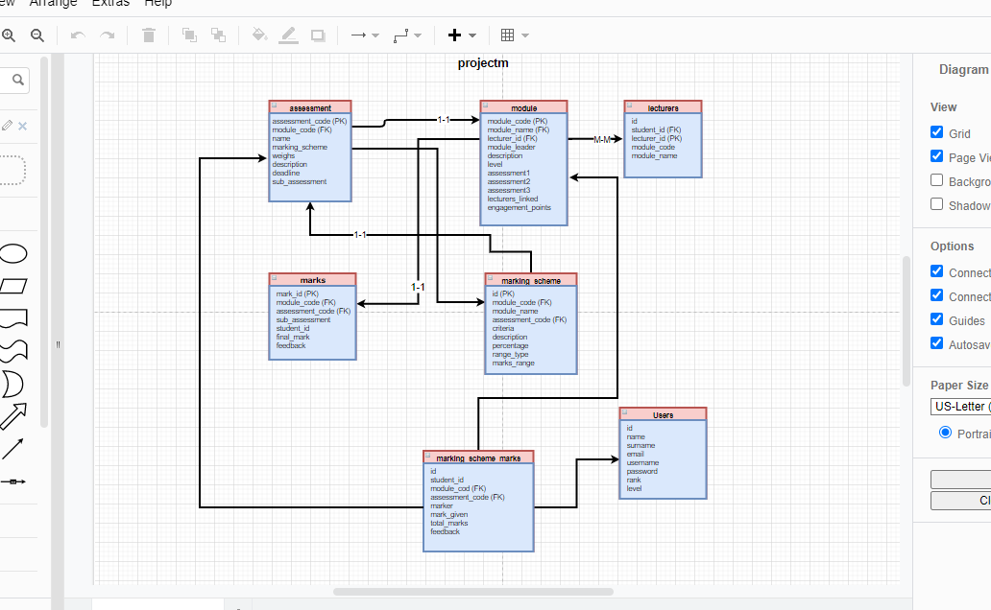

PRODUCT BACKLOG

Backlogs Tasks
I divided this project into ten backlogs, these backlogs are:
- B1: Authentication Backlog, it contains tasks: T1,T2
- B2: Courses Backlog, it contains tasks: T8,T3
- B3: Contact Backlog: it contains tasks:. T6,T7
- B4: Assignments Backlog: it contains tasks:.T16
- B5: ADD Backlog: it contains tasks:.T10,T15
- B6: Remove Backlog: it contains tasks:.T11,T14
- B7: Submission Backlog: it contains tasks:.T12
- B8: Edit Backlog: it contains tasks:.T17
- B9: Demo Backlog: it contains tasks:.,T4,T9
- B10: Feedback Backlog: it contains tasks:.T5,T13,T18

Backlog  ID | Backlog | Backlogs Tasks | Sprint  Number
B1 | Authentication | T1+T2 | 1
B2 | Courses | T8+T3
B3 | Contact | T6+T7
B4 | Assignments | T16
B5 | ADD | T10+T15
B6 | Remove | T11+T14
B7 | Submission | T12
B8 | Edit | T17
B9 | Demo | T4+T9
B10 | Feedback | T5+T13+T18

Sprints List

ID | Sprint Number | Start-Date | End-Date | Duration  (Days)
1 | S1 | Friday, October 15, 2021 | Wednesday, October 20, 2021 | 5
2 | S2 | 5/Nov/2021 | 28/Nov/2021
3 | S3 | 29/Nov/2021 | 5/Dec/2021

Task List (user may be student or professor or TA)
Priority | Task  ID | Backlog Task | Sprint  Number
1 | T1 | As a user, I need to be able to log in into the “Grade Happy” using a registration number, and my  password. | 1
2 | T2 | As a user, I need to be able to change my password if I forget it | 1
3 | T3 | As a student, I need to be able to see registered courses, | 2
4 | T4 | As a student, I need to be able to see the instructor's name of my  courses | 2
5 | T5 | As a student, I need to be able to  see a description for my registered  courses | 2
6 | T6 | As a student, I need to be able to contact with my professor | 2
 | T7 | As a Teacher Assistant, I need to be able to contact with the professor | 2
7 | T8 | As a professor or a Teacher Assistant I need to be able to see my courses | 2
8 | T9 | As a Teacher Assistant or a professor, I need to see the students which  enrolled in the course | 2
9 | T10 | As a Professor, I need to be able to add assignments for students  . | 3
 | T11 | As a Professor, I need to be able to remove assignments for students, unless no grades have been entered for them | 3
11 | T12 | As a student, I need to be able to add a solution for the assignment before the deadline | 3
12 | T13 | As a student, I need to be able to write a comment about assignment | 3
13 | T14 | As a student, I need to be able to remove the submission before the deadline | 3
14 | T15 | As a professor, I need to be able to  Add grades for assignments | 3
15 | T16 | As a student, I need to be able to  see my grades only in assignments | 3
16 | T17 | As a professor, I need to be able to  edit the grade of assignments | 3
17 | T18 | As a Teacher Assistant, I need to  be able to write feedback about  assignment for each student | 3

Get Hub link

https://github.com/Ameer-yaish/Happy-Grades

Trello Link

https://trello.com/b/sjvuiFG0/happy-grade

